**Feature Scaling**

We discussed previously that the scale of the features is an important consideration when building machine learning models. Briefly:

**Feature magnitude matters because:**

* The **regression coefficients of linear models** are directly influenced by the **scale of the variable.**
* **Variables with bigger magnitude / larger value** range **dominate over those with smaller magnitude / value range**
* **Gradient descent converges** faster when **features are on similar scales**
* **Feature scaling helps decrease** the time to **find support vectors for SVMs**
* **Euclidean distances** are sensitive to **feature magnitude.**
* Some algorithms, **like PCA require the features to be centered at 0.**

**The machine learning models affected by the feature scale are:**

* Linear and Logistic Regression
* Neural Networks
* Support Vector Machines
* KNN
* K-means clustering
* Linear Discriminant Analysis (LDA)
* Principal Component Analysis (PCA)

**Feature Scaling**

**Feature scaling** refers to the methods or techniques used to normalize the range of independent variables in our data, or in other words, the methods to set the feature value range within a similar scale. Feature scaling is generally the last step in the data preprocessing pipeline, performed **just before training the machine learning algorithms**.

There are several Feature Scaling techniques, which we will discuss throughout this section:

* **Standardisation**
* **Mean normalisation**
* Scaling to minimum and maximum values - **MinMaxScaling**
* Scaling to maximum value - **MaxAbsScaling**
* Scaling to quantiles and median **- RobustScaling**
* **Normalization to vector unit length**

In this notebook, we will discuss **Standardisation**.

=================================================================

**Standardisation**

Standardisation involves centering the variable at **zero, and standardising the variance to 1**. The procedure involves subtracting the mean of each observation and then dividing by the standard deviation:

**z = (x - x_mean) / std**

The result of the above transformation **is z,** which is called the **z-score**, and

represents **how many standard deviations a given observation deviates from the mean**.

A **z-score specifies the location of the observation within a distribution** (in numbers of standard deviations respect to the mean of the distribution).

The sign of the **z-score (+ or - ) indicates** whether the observation **is above (+) or below ( - )** the mean.

The shape of **a standardised (or z-scored normalised) distribution** will be identical to the original distribution of the variable. If the original distribution is normal, then the standardised distribution will be normal. But, if **the original distribution is skewed**, then the standardised distribution of the variable will also be skewed. In other words, **standardising a variable does not normalize the distribution of the data** and if this is the desired outcome, we should implement any of the techniques discussed in section 7 of the course.

In a nutshell, standardisation:

* centers the mean at 0
* scales the variance at 1
* **preserves the shape of the original distribution**
* the minimum and maximum values of the different variables may vary
* preserves outliers

Good for algorithms that require features centered at zero.

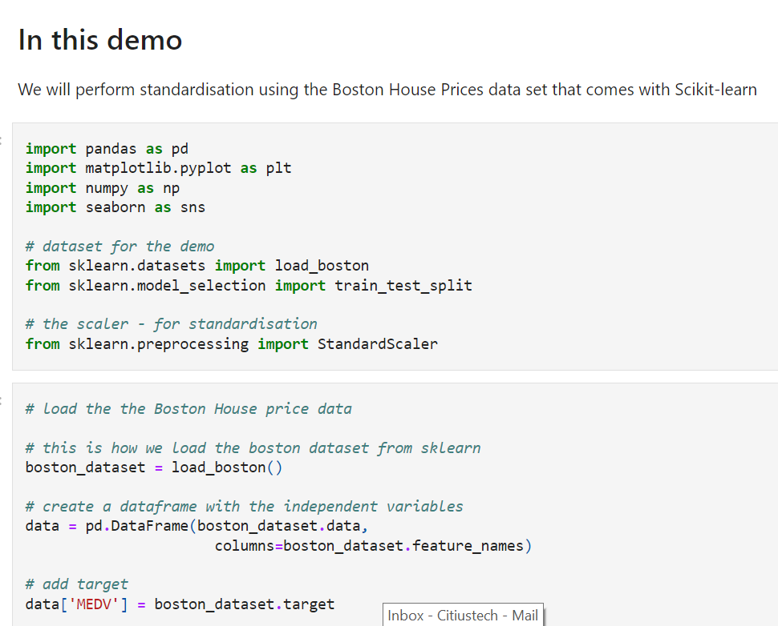

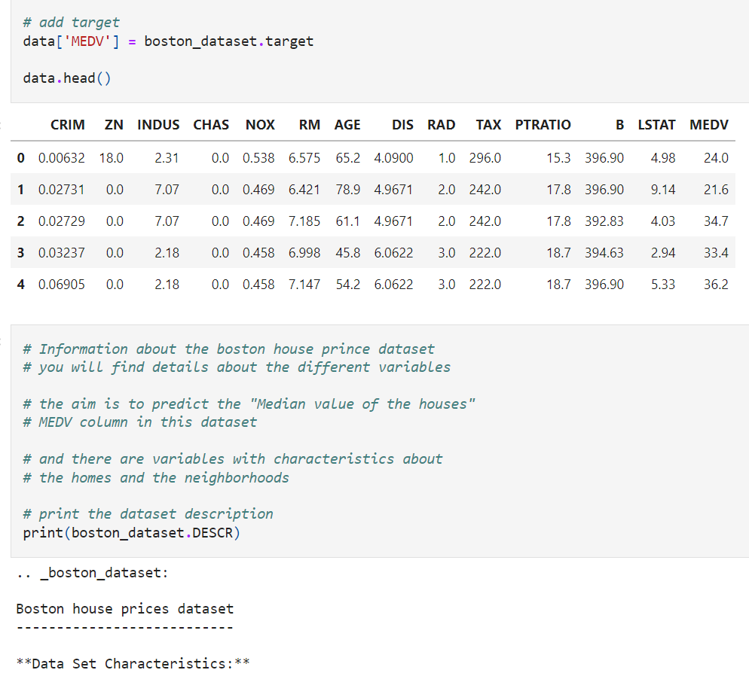

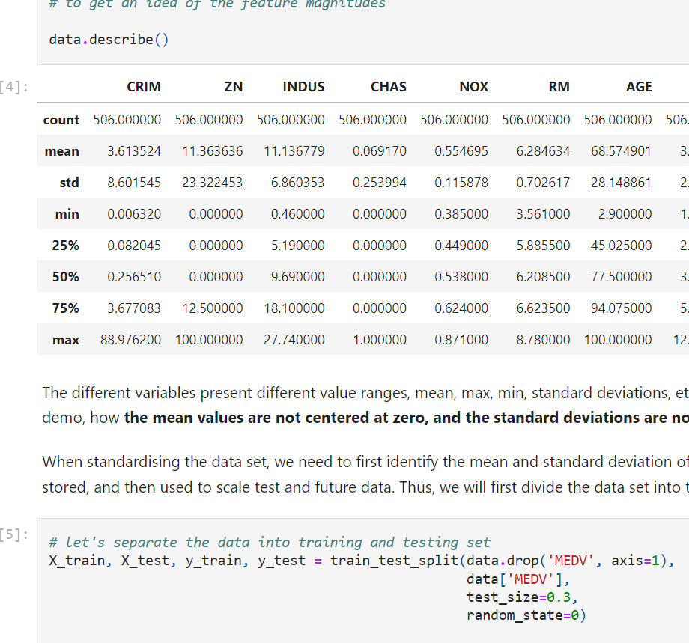

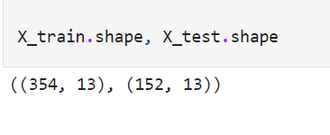

**Standardisation**

The StandardScaler from scikit-learn removes the mean and scales the data to unit variance. Plus, it learns and stores the parameters needed for scaling. Thus, it is top choice for this feature scaling technique.

On the downside, you can't select which variables to scale directly, it will scale the entire data set, and it returns a NumPy array, without the variable values.

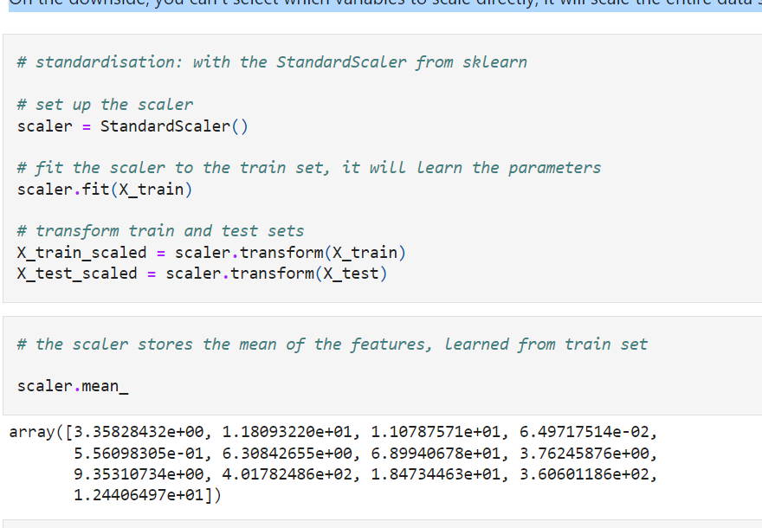

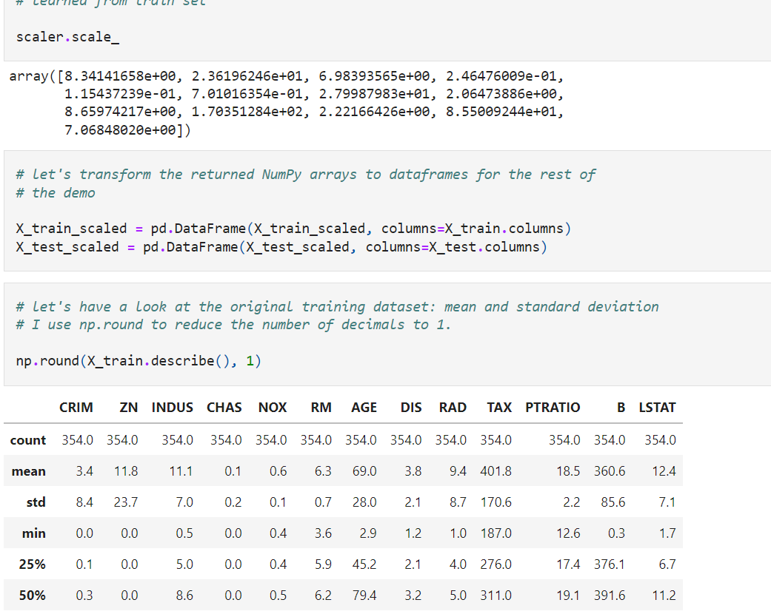

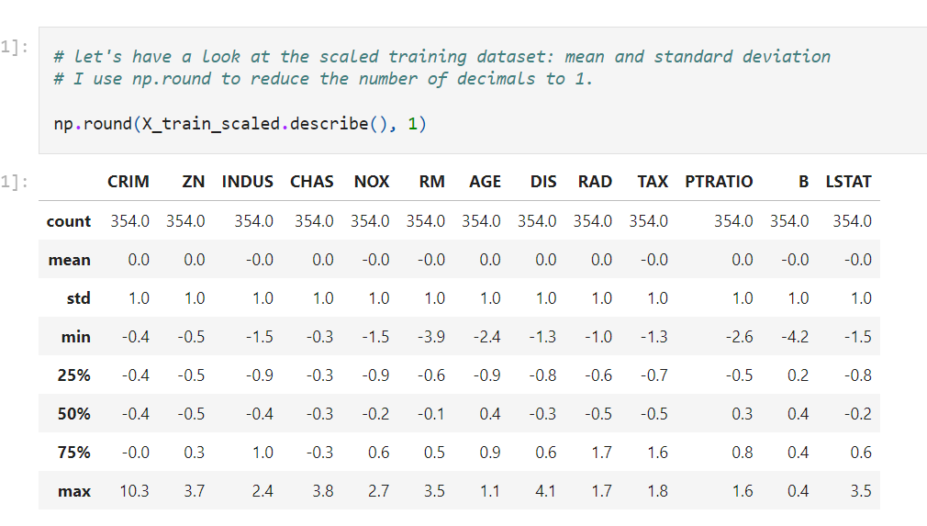

As expected, the **mean of each variable**, which **were not centered at zero**, is now around zero and the **standard deviation is set to 1.** Note however, that the **minimum and maximum values** vary according to how spread the variable was to begin with and is highly influenced by the presence of outliers.

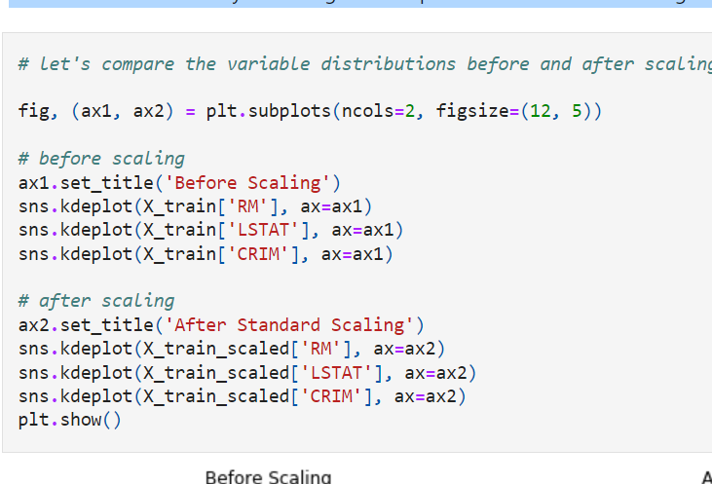

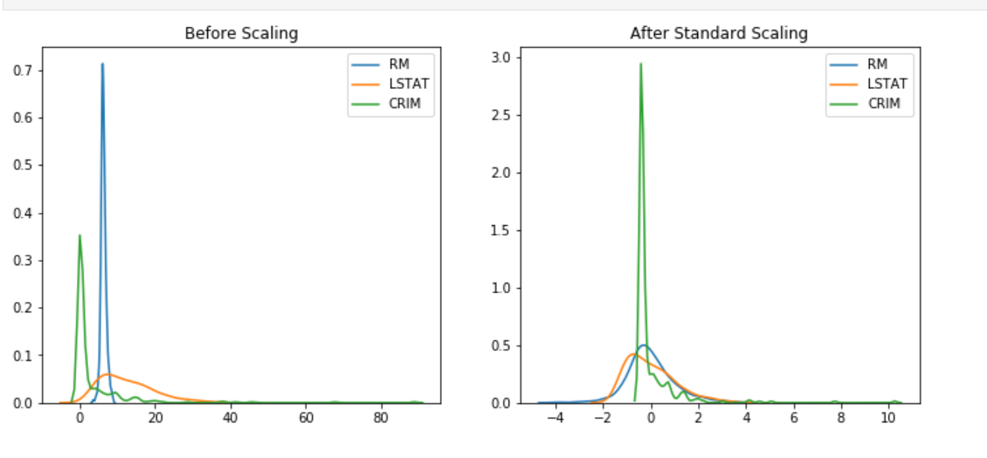

Note from the above plots how **standardisation centered all the distributions at zero**, but it **preserved their original distribution.**

The **value range is not identical**, but it looks **more homogeneous across the variables**.

Note something interesting in the following plot:

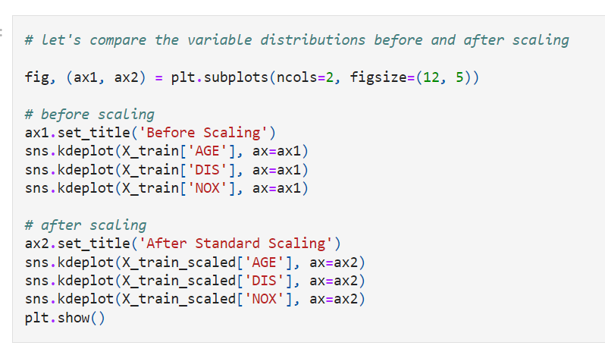

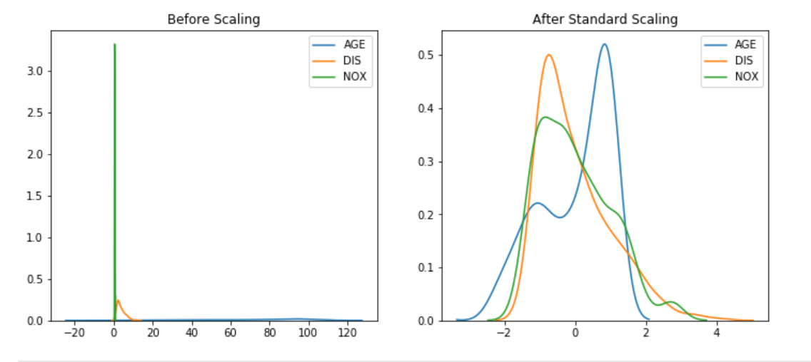

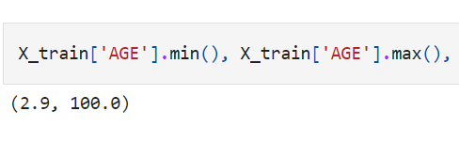

In the above plot, we can see how, by scaling, the variable NOX, which varied across a very **narrow range of values [0-1],** and AGE which varied **across [0-100],** now spread over a more homogeneous range of values, so that we can compare them directly in one plot, whereas before it was difficult. In a linear model, AGE would dominate the output, but after standardisation, both variables will be able to have an input (assuming that they are both predictive).

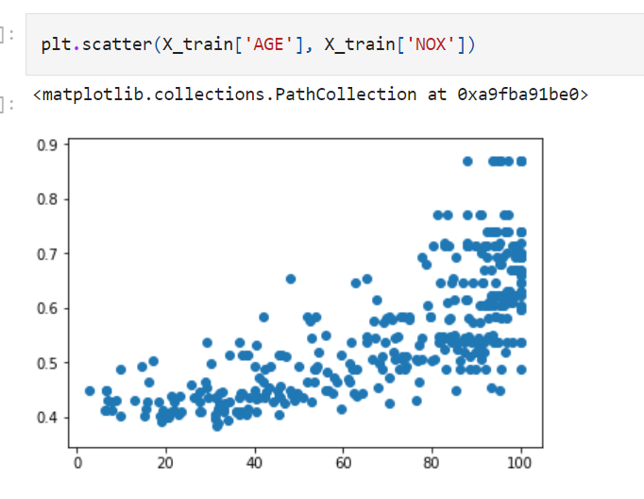

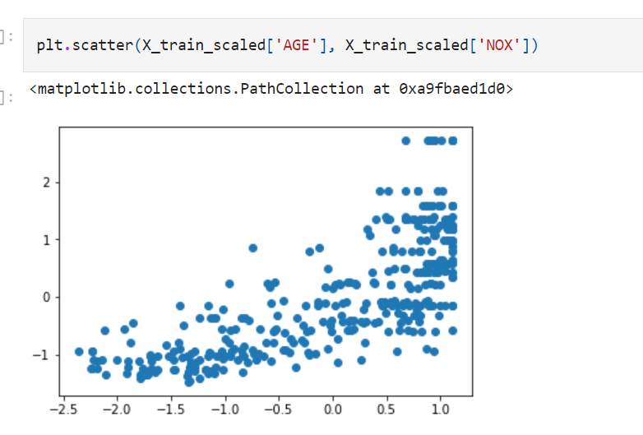

**Mean Normalisation**

Mean normalization involves centering the **variable at zero,** and **re-scaling to the value range**. The procedure involves **subtracting the mean of each observation** and then dividing by difference between the minimum and maximum value:

**x_scaled = (x - x_mean) / ( x_max - x_min)**

The result of the above transformation is a distribution that is

**centered at 0**, and

its **minimum and maximum** values are within the range of **-1 to 1.**

The shape of a mean **normalised distribution** will be **very similar to the original distribution** of the variable, **but the variance may change**, so not identical.

Again, this technique will not **normalize the distribution of the data** thus if this is the desired outcome, we should implement any of the techniques discussed in section 7 of the course.

In a nutshell, mean normalisation:

* centers the mean at 0
* variance will be different
* may alter the shape of the original distribution
* the minimum and maximum values squeezed between -1 and 1
* preserves outliers

Good for algorithms that require features centered at zero.

**In this demo**

We will perform mean normalisation using the Boston House Prices data set that comes with Scikit-learn

There is no Scikit-learn transformer for mean normalisation, but we can implement it using a combination of 2 other transformers that I will discuss in detail in the next notebooks. We will also implement it manually with pandas.

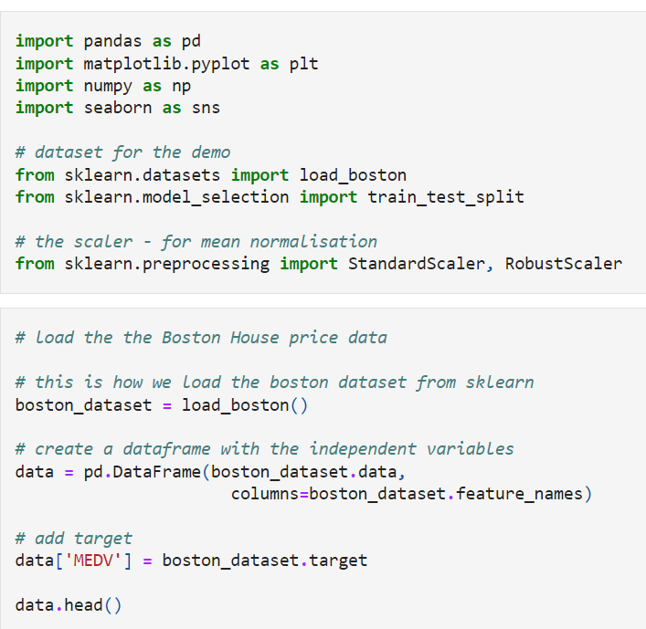

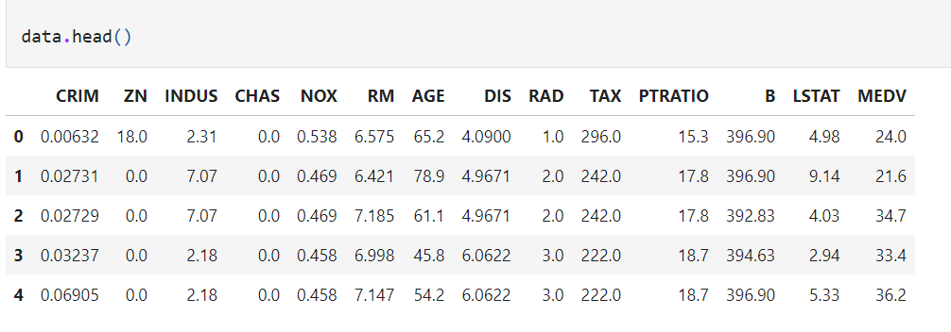

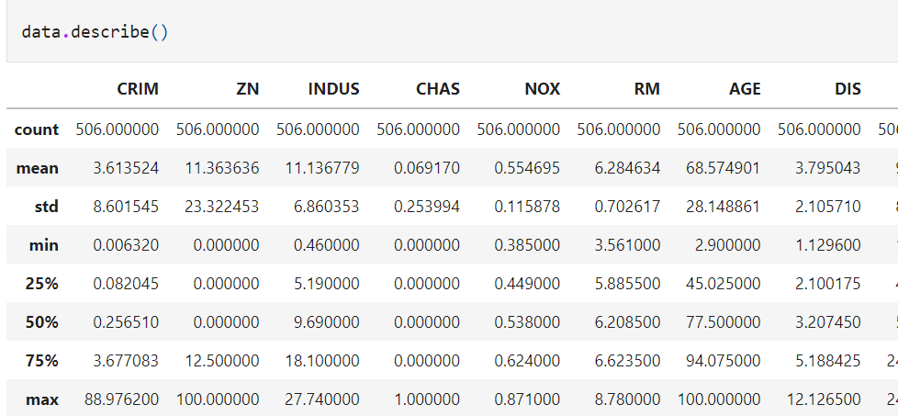

The different variables present **different value ranges**, mean, max, min, standard deviations, etc. In other words, they show different magnitudes or scales. Note for this demo,

how

**the mean values are**

**not centered at zero, and the min and max value vary across a big range**.

When performing **mean normalisation on the data set**, we need to

first identify the

mean and

minimum and maximum values of the variables.

**These parameters need to be learned from the train set**, stored, and then used to scale test and future data. Thus, we will first divide the data set into train and test, as we have done throughout the course.

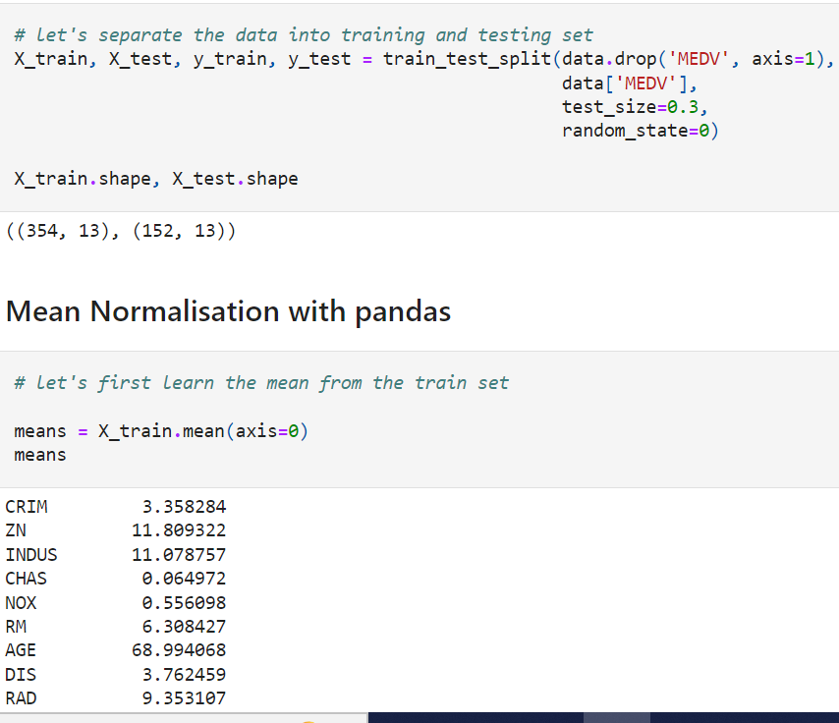

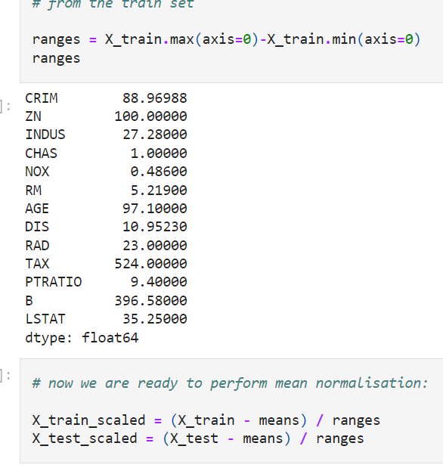

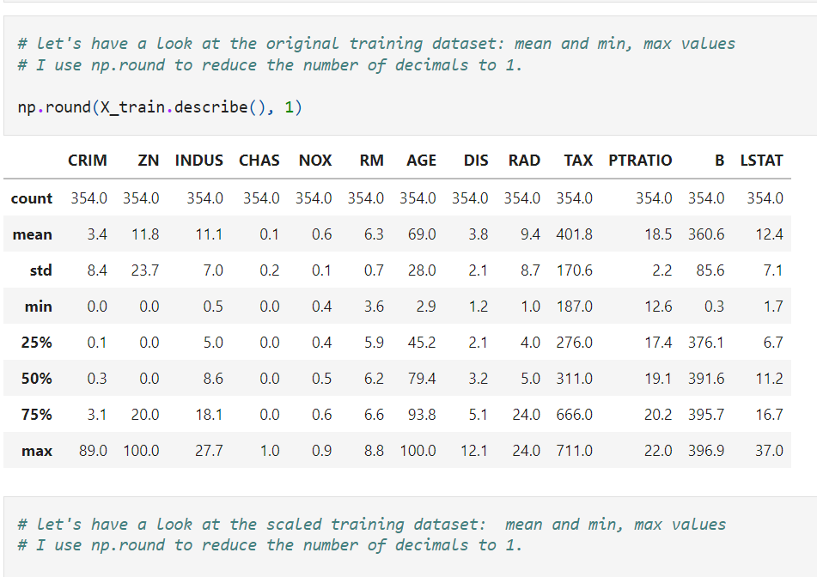

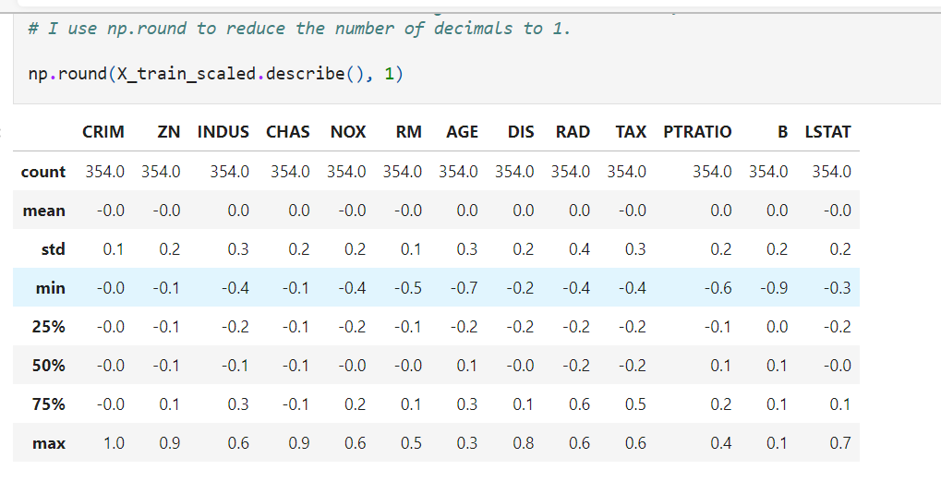

As expected, the mean of each variable, which were **not centered at zero**, is **now around zero** and the min and max values vary approximately between -1 and 1. Note however, that the standard deviations vary according to how spread the variable was to begin with and is highly influenced by the presence of outliers.

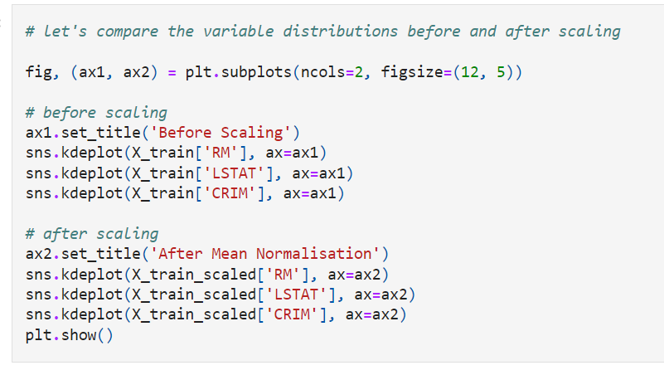

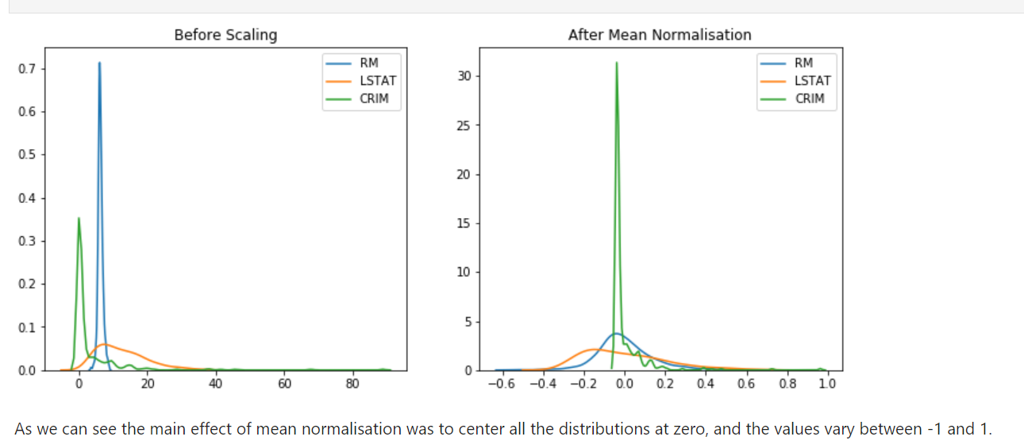

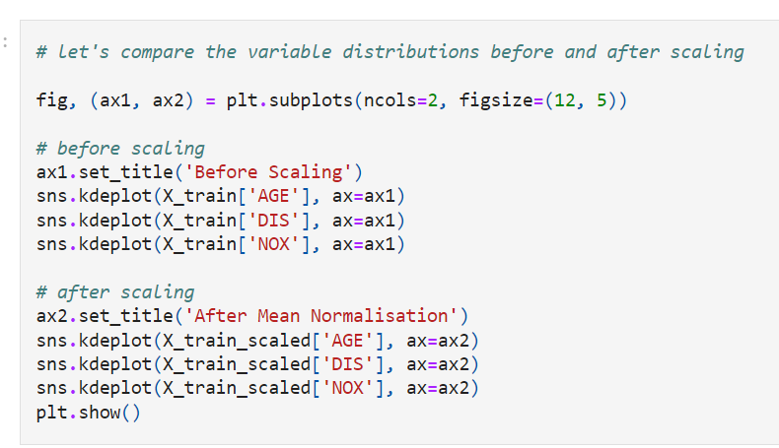

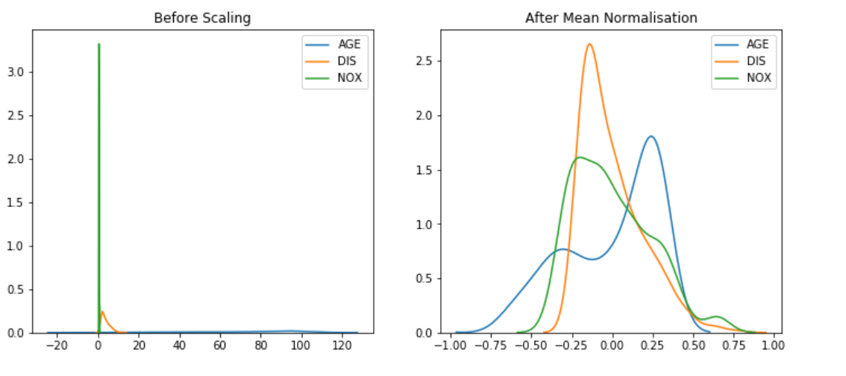

Compare these plots, with those derived by standardisation in the previous notebook to better understand how these procedures are not identical.

**Mean Normalisation with Scikit-learn: work-around**

We can implement mean normalisation by combining the use of 2 transformers. A bit dirty, if you ask me, but if you are desperate to implement this technique with sklearn, this could be a way forward.

